WORLD THE NATURAL WORLD

CONTENT AREAS Art, Biology, History, Geography, Science

ZONES A Horror Story
Animal Migration
Animal Types
Animals Communicating
Climate Change
Food Chains

TOPIC FOCUS Categorizing animals
Environmental changes
Migration patterns
Recognizing links in food chains

LEARNING OBJECTIVES OF THIS WORLD
To explore the effects of climate change on animals
and on the environment.
To demonstrate how different parts of the natural world are interconnected.
To explore and discuss the place and effect of humans on the natural world.

TARGET LANGUAGE LEVEL
Receptive: Pre-intermediate to Intermediate
Productive: Elementary to Pre-intermediate
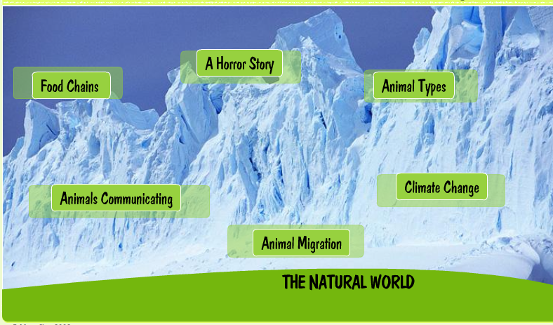
THE NATURAL WORLD: HOME PAGE

BEGORE VIEWING
Ask the students about possible connections between humans and the natural world.

[IWB] Brainstorm their ideas and make a word map on the board.

food
climate change agriculture
environment farming
NATURAL WORLD
+ HUMANS
science exploration
recording
photos

LEAD-IN
Write the titles of the six Zones on the board.
Ask the students what they think the content of these Zones could be.
[IWB] Write their ideas on the board.

ON-SCREEN
1. Focus on the picture.
[IWB] Ask the students why it illustrates ‘The Natural World’.

Possible answer
‘It shows a very cold place, with no sign of humans.’

2. Explore the picture
[IWB] Ask the students to look carefully at it and suggest answers to these questions:

‘ Is it your country?’ (It is in the Arctic)
‘ What human things can you see?’ (none)
‘ What natural things can you see? (mountains, snow, rocks (?), sky...)
‘ What do you feel when you look at it? (cold, excited, curious...)

Ask the students what the picture shows about these things:
- weather, time of day, human activities, animal life, the climate

FOLLOW-UP
Ask the students to suggest or bring in photos that illustrate ’The Natural World’ for them.

