ZONE A HORROR STORY
CONTENT AREA Geography, History, Science

TOPIC FOCUS The threats to albatrosses in the South Atlantic
VOCABULARY FOCUS albatrosses
mice
LANGUAGE FOCUS Simple Present/Simple Past tenses for narration
will future (predicting)
Why?/Because/ So
Skills focus: Storytelling (sequencing)
Writing emotive descriptions

LEARNING OBJECTIVES OF THIS ZONE

Following a ‘cause and effect’ story

Understanding how chance events can affect an environment

Using facts and information as a context for writing

DOWNLOADABLE FILES
You may like to print these out for each student or pair of students.
WORKSHEET After SCREEN 1 INTRODUCTION
WEB PROJECT After SCREEN 5 SELECTING FACTS

OTHER PROJECT WORK SUGGESTIONS
Finding out about similar environmental and human threats to other species.

WEBSITES
For the teacher (maps) www.wikipedia.org (key in ‘Tristan da Cunha map’)

For the web project www.bbc.co.uk/radio4

TARGET LANGUAGE LEVEL
Receptive: Pre-intermediate Productive: Pre-intermediate

ROUTE(S) THROUGH THIS ZONE: Linear > Parallel > Linear

SCREEN 1 A Horror Story: Introduction

[WORKSHEET] ⬇

SCREEN A2 The characters B2 The location C2 The background
⬇
SCREEN 3 Albatrosses and mice
⬇
SCREEN 4 The problem
⬇
SCREEN 5 Selecting facts

[WEB PROJECT]

INTRODUCING THIS ZONE
Before-viewing classroom activities

1. Film/Movie language

[IWB] Write these words on the board:

actor background character

development location plot

Ask the students to suggest a meaning for each one.

Encourage them to use dictionaries if necessary.

Write their suggestions on the board.

Alternatively, ask them to match the words with these meanings:

- the ideas and events that happened before the film begins. (background)

- a person or animal (a ‘living being’) in a film (character)

- the way the story progresses during the film (development)

- the place where the film happens (location)

- the story of the film (plot)

- a person who acts in a film or play (actor)

2. Horror films/movies

Ask the students if they enjoy horror films.

Ask them why (not).

Take a class vote on this.

3. Sailing ship routes

Use an atlas or website to locate:

- the South Atlantic

- Tristan da Cunha

- Gough Island (it may be too small to find!)

If the students have learned about trade routes in History or Geography, ask them to suggest where the ships might have been coming from (Europe) and going to (Australia). You can use the map on the www.wikipedia.org site for the Tristan da Cunha group of islands.

Discuss the fact that sailing ships were small and that the sailors needed to land to find fresh water, fruit and vegetables, as well as meat, whenever possible.

Use L1 for this as necessary.

Ask if they have seen any films about sailing ships. e.g. Pirates of the Caribbean.

Who were the characters? Who were the actors? What was the location?
 

  

SCREEN 1 A HORROR STORY: INTRODUCTION
Interaction type: Input: visual + text
Aim: To introduce the three ‘elements’ of this story.

LEAD-IN
[IWB] Write these words on the board:
characters location background
Ask for suggestions for what each one means.

ON-SCREEN
1. [IWB] If possible, reveal the five lines of text at the top of the screen.
Why do some animals have ‘exciting’ lives’?
Ask for examples.
Possible answers
They have a lot of enemies.
People kill them.

2. [IWB] Reveal the whole picture. Ask for words to describe it.
Write these on the board.
Possible answers
beautiful
calm
dark
mysterious
romantic

3. [IWB] Focus on each of the words in the middle of the screen.
Ask which of these they want to focus on first. Remind the students that the story will be like a movie. As they go through the Zone, they can decide what type of movie it would make.

Follow-up
WORKSHEET
[IWB] Introduce the Worksheet or print out copies.
Explain that they should complete Part A while they visit the various parts of the Zone. They can complete Parts B and C at the end.

Exit to: THE CHARACTERS
or to: THE LOCATION
or to: THE BACKGROUND

or on to: ALBATROSSES AND MICE
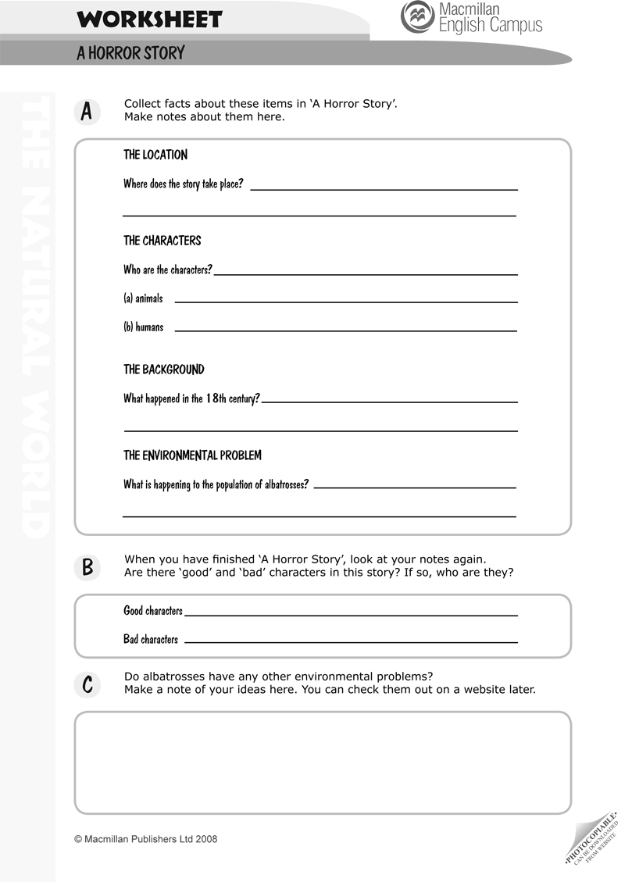
SCREEN A2 THE CHARACTERS
Interaction type: Input: text + visual + audio
Aim: To introduce one of the main characters: the albatross.
Hint: Look at the photo of one of the main characters.

LEAD-IN
Ask the students for any information they know about albatrosses.
Possible answers
- Seabirds
- Live in the South Atlantic and the North Pacific
- In danger of extinction

ON-SCREEN
1. [IWB] Focus on the bird’s picture. Ask the students how they might describe it.

2. [IWB] Listen to the audio and read the text.

3. [IWB] Focus on the text on the left. Ask for volunteers to come and identify the characters it mentions. (huge mice young birds albatrosses)
Highlight or circle these with one colour.

Tell them that there some important adjectives in this description. Ask them to identify these. Highlight or circle them in a different colour. (huge young hungry)

Follow-up
Ask the students to use the information to fill in a section of Part A of their Worksheets.

Ask for suggestions of what the story might be about, using these adjectives and the characters as a clue.

Exit to next screen: THE LOCATION
or to: THE BACKGROUND

or back to THE INTRODUCTION
SCREEN B2 THE LOCATION
Interaction type: Input: text + visual + audio
Aim: To establish the location of the story.
Hint: You can also use an atlas to locate this place. Check how many kilometres from here to the next place.

LEAD-IN
Use an atlas to locate Gough Island. Ask the students to imagine what it is like.
If necessary, go back to the INTRODUCTION screen and check the picture and the text. (It is small and rocky.)

ON-SCREEN
1. [IWB] Focus on the map.
Listen to the audio and then read the text on the left.

2. [IWB] Ask the students to notice the size of the island.
(eight kilometres long and five kilometres wide)

Follow-up
Ask the students to use the information to fill in a section of Part A of their Worksheets.

Ask for suggestions of places that are eight and five kilometres away from the school. You may like to draw a plan of this on the board to give an idea of the size if the island.

Exit to next screen: THE BACKGROUND
or to: THE CHARACTERS

or back to: THE INTRODUCTION
SCREEN C2 THE BACKGROUND
Interaction type: Input: text + visuals+ audio
Aim: To describe the background to the story.
Hint: The ‘background’ to a story or movie is any extra information about the events or people in it.

LEAD-IN
Remind the students of anything you discussed in the pre-viewing activities about sailing ships and South Atlantic trade routes.

ON-SCREEN
1. [IWB] Focus on the two pictures. Ask the students to make up statements about the ship and the place.
Possible answers
It’s a sailing ship.
It’s an old ship.
It’s probably sailing between Europe and Australia.

It might be an island.
It’s rocky.
I can’t see any people.

2. [IWB] Highlight the two questions in the rubric. Tell the students they will find the answers in the book.
Answers
The mice came from a sailing ship.
The environmental problem is that mice and albatrosses cannot live together.

3. [IWB] Read the book and listen to the audio.
Page 1 Ask the students why ships stopped at Gough Island
(to find food and water) and what type of food they found (fruit and vegetables).
Discuss why this was important then (Because the ships had no electricity! They had no fridges. Food went bad quickly.)

Pages 2 and 3 Find out what the mice did (they went onto the island) and why they grew bigger (there were no people there and they could find food).

Who were the other inhabitants of the island (albatrosses)?

Ask the students to speculate what happened. Ask them to write their suggestions in their notebooks to check out later in the Zone.

Page 4 Ask for the students’ ideas about the environmental problem. Who caused it originally? (humans/mice) What is causing it now?

Again, ask them to make a note of their ideas to check out later in the Zone.

Follow-up
Ask the students to use the information to fill in a section of Part A of their Worksheets.

Exit to next screen: THE CHARACTERS
or to: THE LOCATION

or back to: THE INTRODUCTION

SCREEN 3 ALBATROSSES AND MICE
Interaction type: Input: text + images
Aim: To present the current situation
Hint: Remember: mice plus albatrosses make a big environmental problem!

LEAD-IN
Remind the students that this story could be a horror movie.
Ask them to say what features of the background, location or characters support this.

Remind them of the warning on the INTRODUCTION screen, ‘It isn’t a happy story!’
ON-SCREEN
1. [IWB] Focus on the two photos. Ask for volunteers to come and identify the mice.

2. [IWB] Look at the rubric. Ask the students if they can suggest what the problem is. Tell them they will find out what the scientists say. (The mice are killing around 1 million birds every year!)

3. [IWB] Read the book and listen to the audio.
Use the A-Z button to check unfamiliar words in the Word List.

Page 1 Ask the students why the young birds are left alone (The adults fly away to find food for them). Why is this is necessary? (Gough Island is very small and rocky.)

Pages 2 and 3 Ask for volunteers to come and highlight or circle the descriptions of the young birds.

Then ask these questions:
How tall are they: one metre.
Can they fly? No!
What do the mice like to eat? Young birds
Why don’t the birds escape? They can’t fly!
So what happens? A massacre.

Follow-up
Ask the students if they predicted the scientists’ description of the problem. Are they surprised?

Exit to next screen: THE PROBLE M
SCREEN 4 THE PROBLEM
Interaction type: Sequence (drag and drop)
Aim: To check understanding of the story
Hint: Remember – adult albatrosses fly long distances to find food for the young birds. The young birds sit on the nests and wait for their parents to return.

LEAD-IN
Ask the students to make a summary of the story.

ON-SCREEN
1. [IWB] Tell the students that the blue text and the jumbled sentences make a summary too. Ask for volunteers to rearrange the sentences by dragging them to the right.

Check the suggested answer. Discuss other possible variations.
Suggested answer
Young albatrosses can’t fly.
Mice like to eat young birds.
The mice eat the young birds.
The birds can’t escape
It’s a battle between giant mice and young birds.
Every year, more and more albatrosses die.

2. Compare this summary with their own versions.

Follow-up
Ask the students to use these summaries to make an advert for a movie based on the story.

Exit to next screen: SELECTING FACTS

SCREEN 5 SELECTING FACTS
Interaction type: Single choice
Aim: To use information from the story to choose correct solutions.
Hint: Go back and read the booklet again if necessary.
LEAD-IN
1. Ask the students to say what they have learned about the characters and the environmental problem. Encourage them to refer to the completed Part A of their Worksheets.

2. You may like to read and listen to the story again.

ON-SCREEN
1. [IWB] Ask the students to suggest how to complete the gapped sentences..
They can either do this by clicking on the menus and selecting the correct item, or they can write the answers first in their notebooks, and then click and check.

2. [IWB] Check the answers.
Answers
1. South Atlantic
2. live on
3. far from
4. find food and water
5. Mice
6. bigger
7. cannot move from their nests.
8. young

Follow-up
1. WORKSHEET
Ask the students to complete Parts B and C now, using the information from this Zone and their own ideas.

2. WEB PROJECT
[IWB] Check through this on the IWB or print out copies.
Go to www.bbc.co.uk/radio4
Click on SCIENCE in the Programme Genres panel on the left.
Key in ‘Gough Island’ in the search box.
Find the report dated 24 July 2005.

PART A Ask the students to find the two solutions which the scientist suggests. They discuss whether they agree with these. Use L1 if necessary.

PART B This gives information about a another environmental problem for albatrosses: plastic.
Key in ‘Midway’ in the search box on the same website.
Click on the report dated 26 March 2008.
The students note some of the things found in the birds’ stomachs.

PART C This gives an account of a campaign to stop the use of plastic.
On the same website, key in ‘Modbury’ and then click on ‘Town dumps plastic bags’.

The students can discuss campaigns that individuals can run to fight environmental problems, and design posters or webpages for them.

OTHER PROJECT

Ask the students to draw a storyboard for each part of the story and to write a caption for it.

They can decide a good title for a film about this story, and design a poster for it.

Exit back to HOME PAGE
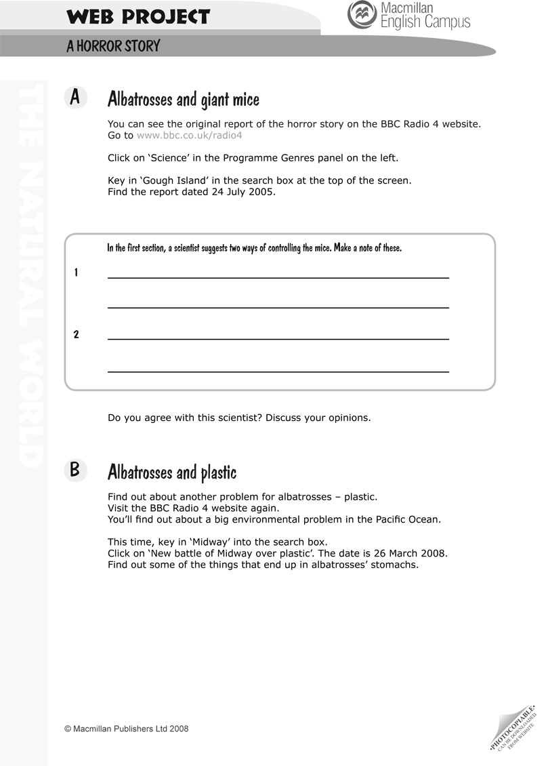
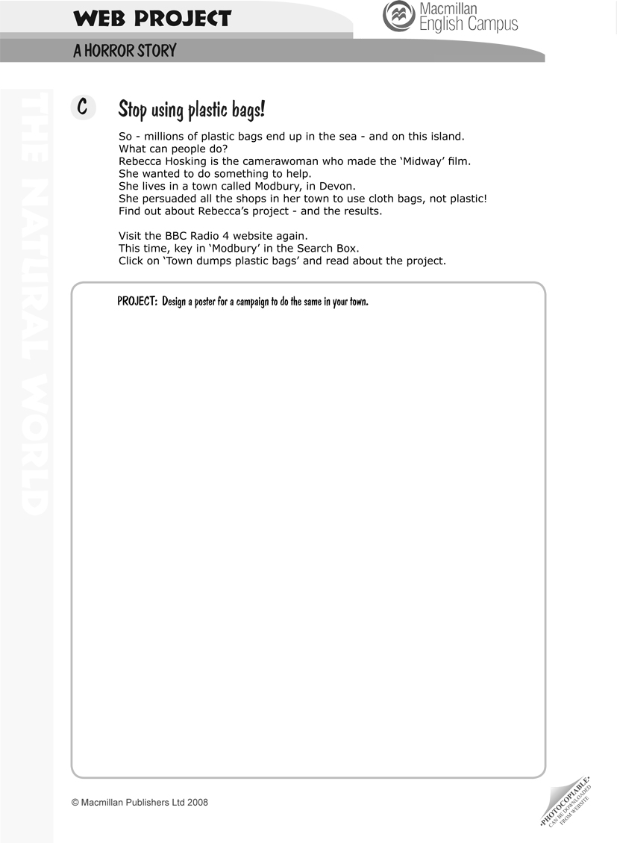

WORKSHEET PDF: ANSWERS
1.
THE LOCATION Gough Island in the South Atlantic.

THE CHARACTERS a. Albatrosses and mice
b. Sailors

THE BACKGROUND Ships stopped at Gough Island for food and water.

THE ... PROBLEM The population is becoming smaller.

2.
GOOD CHARACTERS
[Students’ own answers.]

BAD CHARACTERS
[Students’ own answers.]

3.
[Students’ own answers.]

WEB PROJECT: ANSWERS
A
1 poison

2 diseases

B handle of a toothbrush, bottle top, a piece of fishing net, plastic cigarette lighter

C
[Students’ own answers.]
AUDIOSCRIPT

SCREEN 1: A horror story: introduction

The lives of some animals are as exciting as a movie!

This true story has drama, suspense, excitement … and sometimes tragedy and horror, too.

It’s about some special animals on a small, rocky island.
Warning: It isn't a happy story!

SCREEN A2: The characters
The characters in this Horror Story aren’t humans. They are animals: huge mice and young birds. These birds are albatrosses.

Albatrosses make their nests on Gough Island. The young birds are always hungry, so their parents travel huge distances to look for food.

The young birds stay in the nests. Sometimes the adults leave them for eight months!

SCREEN B2: THE LOCATION:
Gough Island is in the South Atlantic.
It’s part of the Tristan da Cunha group of islands.
It’s a small island: eight kilometres long and six kilometres wide.

SCREEN C2: The background

In the past, there was no electricity on ships. Fresh water and were a problem on long sea journeys.

In the 19th century, a lot of ships stopped at Gough Island. It was a good place to find fresh water. The sailors collected fruit and vegetables there, too.

These ships were often full of mice. When the sailors went onto the island, the mice went too. They stayed there.

There were no people on Gough Island, so these mice had a great life.
The result? They grew bigger and bigger!

Don’t forget the other characters in this story!

There were also a lot of birds on the island. Hundreds of albatrosses had their nests there. Every year, young birds waited for their parents to return with food.

The situation today
Mice plus Albatrosses? A big environmental problem!

SCREEN 3: Albatrosses and mice

Albatrosses make their nests on Gough Island. The adults lay their eggs there.

When the eggs hatch, the parents go to find food for the young birds. They fly huge distances and are often away for several months!

The young birds wait for their parents to return. A young albatross is large – it can be one metre tall - but it cannot fly.

It can turn round in the nest, but that’s all.

Remember the big mice? Well, they like to eat the young birds.
So they attack the young albatrosses as they sit on the ground.
The meat is delicious!

The birds cannot escape. It’s a massacre!

The environmental problem:

Albatrosses are becoming rarer in the South Atlantic. Their numbers are going down.

Scientists calculate that these mice are killing around 1 million birds each year in
these islands.

This is a big environmental problem.

WORD LIST
SPECIALIZED VOCABULARY USED WITHIN THIS ZONE
NOUNS
background 4 The background to a story is any extra information that you
need about what has happened before the story begins. This
helps you to understand the story better
battle 5 a fight between two armies that are at war. You also use
‘battle’ to mean a struggle between two groups with different
aims
character 3 The characters in a story are the people in it
drama 1 something unusual or exciting that happens
excitement 1 a feeling of happiness, interest and enthusiasm
fresh (water) 4 Fresh water is good to drink. It has no salt or pollution in it
horror 1 a strong feeling of shock, fear and disgust
(sea) journey 4 If you go on a sea journey, you travel in a boat or ship,
usually for a long time
location 2 the place where something is or where something happens
massacre 6 the killing of a lot of people or animals in a very violent
and cruel way
nest 3 the place that a bird builds to lay its eggs in and to look after
the baby birds when they are born. Nests are usually made
of leaves, grass and twigs
result 4 The result of an action or situation is the action or situation
that is caused by it
suspense 1 a state of excitement and worry that is caused by having to
wait for something to happen
tragedy 1 an event or situation that is terrible and very sad
warning 1 something such as a notice that tells people about possible
danger or that tells them not to do something

ADJECTIVES
exciting 1 interesting and full of action
full 4 If a place is full of something, there is no space for any more
of it
rare 6 If things are rare, there are not many of them
rocky 1 A rocky place has a lot of rocks in it and not much grass

VERBS
to attack 6 to try to hurt or kill a person or animal
to calculate 6 If you calculate something, you work out a number or an
amount, usually by doing arithmetic
to collect 4 to get things and keep them for a particular purpose. You
can also collect things such as stamps and fossils for a
hobby
to escape 5 to get free and to run away from someone or something
to hatch 6 When a bird, fish or insect hatches, it comes out of its egg
and is born
to lay 6 When a female bird or fish lays eggs, it pushes eggs out of
its body. The eggs will hatch and become new birds or fish
to leave 3 If you leave a place or a person, you go away from them
to stay 3 If you stay in a place, you do not leave it
to turn round 6 to change your position so that you are facing in a different
direction

